What is Maven?
Maven is a project management and automation tool that provides developers a complete build life-cycle framework developed by Apache Software Foundation.
It helps to build projects, dependency, and documentation.
Maven provides developers ways to manage the following: •
- Builds •
- Documentation •
- Reporting •
- Dependencies •
- SCMs •
- Releases •
- Distribution •
- Mailing list
Maven project structure and contents are declared in an xml file, pom.xml, referred as Project Object Model (POM), which is the fundamental unit of the entire Maven system.
Features of Maven:
- Model-based builds: Maven is able to build any number of projects into predefined output types such as jar, war, metadata.
- Backward Compatibility: You can easily port the multiple modules of a project into Maven 3 from older versions of Maven. It can support the older versions also.
- Dependency management including automatic updating.
- A large and growing repository of libraries. •
- Extensible, with the ability to easily write plugins in java or scripting languages.

MAVEN ENVIRONMENT SETUP
Maven is a Java based tool, so the very first requirement is to have JDK installed on your machine.
Step 1 -Verify Java Installation on your Machine Open console and execute the following java command.

OS | TASK | COMMAND
Windows | Open command console | c:\> java -version
Linux | Open command console | $ java -version
Mac | Open command terminal | machine:~joseph$java-version

Step 2: Set JAVA Environment Set the JAVA_HOME environment variable to point to the base directory location where Java is installed on your machine.
OS | OUTPUT
Windows  Linux  Mac | Set the environment variable JAVA_HOME to C:\Program Files\Java\jdk1.7.0_60  export JAVA_HOME=/usr/local/java-current  export JAVA_HOME=/Library/Java/Home

Append Java compiler location to System Path.
OS | OUTPUT
Windows | Append the string “;C:\Program Files\Java\jdk1.7.0.60\bin” to the end of the system variable, Path.
Linux | export PATH=$PATH:$JAVA_HOME/bin/
Mac | not required

Step 3: Download Maven Archive
Download the maven file and extract it.
Ex: Windows apache-maven-3.3.1-bin.zip.
Step 4: Set Maven Environment Variables.
Add M2_HOME, M2, MAVEN_OPTS to environment variables.
OS | OUTPUT
Windows | Set the environment variables using system properties. M2_HOME=C:\Program Files\Apache Software Foundation\apache-maven-3.3.1 M2=%M2_HOME%\bin MAVEN_OPTS=-Xms256m -Xmx512m
Linux | Open command terminal and set environment variables. export M2_HOME=/usr/local/apache-maven/apache-maven3.3.1 export M2=$M2_HOME/bin  export MAVEN_OPTS=-Xms256m -Xmx512m
Mac | Open command terminal and set environment variables. export M2_HOME=/usr/local/apache-maven/apache-maven3.3.1 export M2=$M2_HOME/bin export MAVEN_OPTS=-Xms256m -Xmx512m

Step 6: Add Maven bin Directory Location to System Path.
Now append M2 variable to System Path.
OS | OUTPUT
Windows | Append the string ;%M2% to the end of the system variable, Path.
Linux | export PATH=$M2:$PATH
Mac | export PATH=$M2:$PATH

Step 7: Verify Maven Installation
Now open console and execute the following mvn command.
OS | TASK | COMMAND
Windows | Open command console | c:\> mvn --version
Linux | Open command console | $ mvn --version
Mac | Open command terminal | machine:~joseph$mvn --version

POM
POM stands for Project Object Model. It is an XML file that contains information about the project and various configuration detail used by Maven to build the project(s). POM also contains the goals and plugins.
Before creating a POM, we should first decide the project group (groupId), its name (artifactId) and its version as these attributes help in uniquely identifying the project in repository.
POM Example:

It should be noted that there should be a single POM file for each project.
- All POM files require the project element and three mandatory fields: groupId, artifactId, version. •
- The file will be saved in this format :
groupId-artifactId-version.
- Minimal requirements for a POM: •
Node | Description
Project root | This is project root tag. You need to specify the basic schema settings such as apache schema and w3.org specification.
Model version | Model version should be 4.0.0.
groupId  artifactId | This is an Id of project's group. For example, a banking group com.company.bank has all bank related projects.  This is an Id of the project. This is generally name of the project. For example, consumer-banking.
version | This is the version of the project.  Ex:com.company.bank:consumer-banking:1.0 com.company.bank:consumer-banking:1.1.

BUILD LIFE CYCLE
A Build Life-cycle is a well-defined sequence of phases, which define the order in which the goals are to be executed.
Phase | Description
Prepare resources | Resource copying can be customized in this phase.
validate | Validates if the project is correct and if all necessary information is available.
compile | Source code compilation is done in this phase
Test  Package  install | Tests the compiled source code suitable for testing framework.  This phase creates the JAR/WAR package as mentioned in the packaging in POM.xml.  This phase installs the package in local/remote maven repository.
Deploy | Copies the final package to the remote repository.

Maven has the following three standard life-cycles:
- Clean •
- Default(or build) •
- Site
Clean Life-cycle:
- when mvn clean command executes, Maven deletes the build directory.
Default (or Build) Life-cycle:
- This is the primary life cycle of Maven and is used to build the application.
Site Life-cycle:
- Maven Site plugin is generally used to create fresh documentation to create reports, deploy site.

REPOSITORIES
A maven repository is a directory where all the project jars, library jar, plugins or any other project specific artifacts are stored and can be used by Maven.
Maven repository are of three types:
- Local
- Central
- Remote
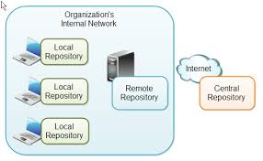
Local Repository:
Maven local repository is a folder location on your machine. It gets created when you run any maven command for the first time. Maven local repository keeps your project's all dependencies (library jars, plugin jars etc.). When you run a Maven build, then Maven automatically downloads all the dependency jars into the local repository.
Central Repository:
- Maven central repository is repository provided by Maven community. It contains a large number of commonly used libraries.
- When Maven does not find any dependency in local repository, it starts searching in central repository using following URL: http://repo1.maven.org/maven2/
- It requires internet access to be searched.
Remote Repository:
Sometimes, Maven does not find a mentioned dependency in central repository as well. It then stops the build process and output error message to console. To prevent such situation, Maven provides concept of Remote Repository, which is developer's own custom repository containing required libraries or other project jars.

PLUGINS
What are Maven Plugins?
Maven is actually a plugin execution framework where every task is actually done by plugins. Maven Plugins are generally used to:
- create jar file
- create war file •
- compile code files •
- unit testing of code
- create project documentation
- create project reports
Plugin syntax is:
mvn [plugin-name]:[goal-name]
For example, a Java project can be compiled with the maven-compiler-plugin's compile-goal by running the following command.
mvn compiler:compile

Plugin | Description
clean | Cleans up target after the build. Deletes the target directory.
compiler | Compiles Java source files.
surefire | Runs the JUnit unit tests. Creates test reports.
jar | Builds a JAR file from the current project.
war | Builds a WAR file from the current project
javadoc | Generates Javadoc for the project.
antrun | Runs a set of ant tasks from any phase mentioned of the build.

CREATING JAVA PROJECT
Maven uses archetype plugins to create projects. To create a simple java application, we'll use maven-archetype-quickstart plugin.
Let's open the command console, go to the C:\MVN directory and execute the following mvn command.
mvn archetype:generate
Maven will start processing and will create the complete java application project structure by providing the groupId, artifactId and version.
Folder Structure | Description
ProjectName(consumerBanking) | contains src folder and pom.xml.
src/main/java | contains java code files under the package structure(com/companyName/bank).
src/main/test | contains test java code files under the package structure (com/companyName/bank).
src/main/resources | it contains images/properties files (In above example, we need to create this structure manually).

BUILD AND TEST JAVA PROJECT
Maven already added Junit as test framework. By default, Maven adds a source file App.java and a test file AppTest.java in its default directory structure.
Open the command console, go the C:\MVN\consumerBanking directory and execute the following mvn command.
C:\MVN\consumerBanking>mvn clean package
Maven will start building the project.
You've built your project and created final jar file, following are the key learning concepts: •
- We give maven two goals, first to clean the target directory (clean) and then package the project build output as jar (package).
- Packaged jar is available in consumerBanking\target folder as artifactId-version.format(consumerBanking-1.0-SNAPSHOT.jar). •
- Test reports are available in consumerBanking\target\surefire-reports folder. • Maven compiles the source code file(s) and then tests the source code file(s). •
- Then Maven runs the test cases.
- Finally, Maven creates the package.
Adding Java Source Files:
Open C:\MVN\consumerBanking(groupId)\src\main\java\com\companyname(artifactId)\bank folder, create a new class in it as example.java.
Update the App class to use example class.
Now open the command console, go the C:\MVN\consumerBanking directory and execute the following mvn command.
mvn clean compile
After Maven build is successful, go to the C:\MVN\consumerBanking\target\classes directory and execute the following java command.
java -cp com.companyname.bank.App

EXTERNAL DEPENDENCIES
Maven does the dependency management using the concept of Repositories. But what happens if dependency is not available in any of remote repositories and central repository? Maven provides answer for such scenario using concept of External Dependency.
The key concept about adding external dependencies in pom.xml file to the maven project:
- External dependencies (library jar location) can be configured in pom.xml in same way as other dependencies. •
- Specify groupId same as the name of the library. •
- Specify artifactId same as the name of the library. •
- Specify scope as system. •
- Specify system path relative to the project location.
Ex:
<project…………………………………………………………
….………………………………………………………..>
<model version>……</model version>
<groupId>…………</groupId>
<artifactId>………..</artifactId>
<version>………….</version>

<dependencies>
<dependency>
<groupId>…………</groupId>
<artifactId>………..</artifactId>
<version>………….</version>
<scope>………….</scope>
</dependency>
<dependency>
<groupId>…………</groupId>
<artifactId>………..</artifactId>
<version>………….</version>
<systempath>…………</systempath> #this is the external dependency
<scope>………….</scope>
</dependency>
</dependencies>
</project>

PROJECT DOCUMENTS
Go to C:/MVN directory where you had created your java consumerBanking application using the examples given in the previous chapters. Open consumerBanking folder and execute the following mvn command.
C:\MVN>mvn site
Maven will start building the project.
Your project documentation is now ready. Maven has created a site within the target directory.
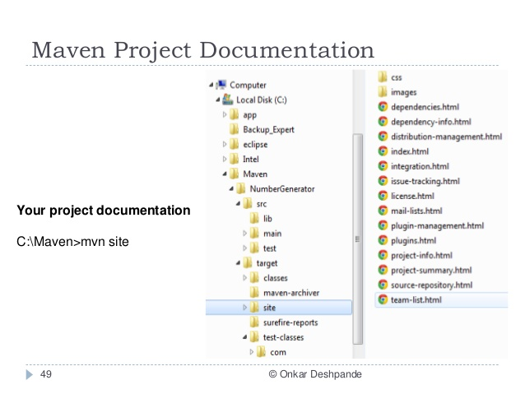
Open C:\MVN\consumerBanking\target\site folder. Click on index.html to see the documentation.

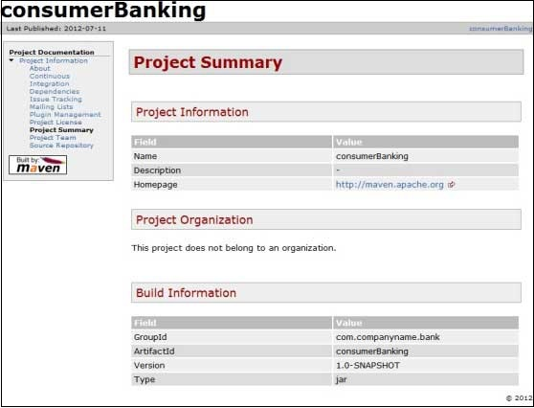

Maven creates the documentation using a documentation-processing engine called Doxia, which reads multiple source formats into a common document model.

PROJECT TEMPLATES
Maven provides users, a very large list of different types of project templates (614 in numbers) using the concept of Archetype. Maven helps users to quickly start a new java project using the following command.
mvn archetype:generate
What is Archetype?
Archetype is a Maven plugin whose task is to create a project structure as per its template. We are going to use quickstart archetype plugin to create a simple java application here.
Using Project Template:
Let's open the command console, go to the C:\ > MVN directory and execute the following mvn command.
C:\MVN>mvn archetype:generate
Maven will start processing and will ask to choose the required archetype.
Press Enter to choose to default option (203: maven-archetype-quickstart).
Maven will ask for particular version of archetype.
Choose org.apache.maven.archetypes:maven-archetype-quickstart
version: 1: 1.0-alpha-1
2: 1.0-alpha-2
3: 1.0-alpha-3
4: 1.0-alpha-4
5: 1.0
6: 1.1
Choose a number: 6:

Press Enter to choose to default option (6: maven-archetype-quickstart:1.1)
Maven will ask for the project detail. Enter project detail as asked. Press Enter if the
default value is provided. You can override them by entering your own value.
Define value for property 'groupId': : com.companyname.insurance
Define value for property 'artifactId': : health
Define value for property 'version': 1.0-SNAPSHOT:
Define value for property 'package': com.companyname.insurance:

Maven will ask for the project detail confirmation. Press enter or press Y.
Now Maven will start creating the project structure.
Created Project:
Now go to C:\ > MVN directory. You'll see a java application project created, named health, which was given as artifactId at the time of project creation. Maven will create a standard directory layout for the project and Maven generates a POM.xml file for the project.
Created App.java:
Maven generates sample java source file, App.java for the project as listed below:
Location: C:\ > MVN > health > src > main > java > com > companyname > insurance > App.java.

Created AppTest.java:
Maven generates sample java source test file, AppTest.java for the project as listed below:
Location: C:\ > MVN > health > src > test > java > com > companyname > insurance > AppTest.java.

SNAPSHOTS
What is SNAPSHOT?
SNAPSHOT is a special version that indicates a current development copy. Unlike regular versions, Maven checks for a new SNAPSHOT version in a remote repository for every build.
Snapshot vs Version:
In case of Version, if Maven once downloaded the mentioned version, say dataservice:1.0, it will never try to download a newer 1.0 available in repository. To download the updated code, data-service version is be upgraded to 1.1.
In case of SNAPSHOT, Maven will automatically fetch the latest SNAPSHOT (data-service:1.0-SNAPSHOT) every time.

Open the command console, go to the C:\ > MVN > app-ui directory and execute the following mvn command to download the latest snapshot build.
C:\MVN\app-ui>mvn clean package -U
Maven will start building the project after downloading the latest SNAPSHOT of data-service.

BUILD AUTOMATION
Build Automation defines the scenario where dependent project(s) build process gets started once the project build is successfully completed, in order to ensure that dependent project(s) is/are stable.
Example:
Consider a team is developing a project bus-core-api on which two other projects app-web-ui and app-desktop-ui are dependent. app-web-ui and app-desktop-ui project is using 1.0-SNAPSHOT of bus-core-api project.
Now, teams of app-web-ui and app-desktop-ui projects require that their build process should kick off whenever bus-core-api project changes.
We can proceed with the following two ways: •
- Add a post-build goal in bus-core-api pom to kick-off app-web-ui and appdesktop-ui builds. •
- Use a Continuous Integration (CI) Server like Hudson to manage build automation automatically.
Using Maven:
Update bus-core-api project pom.xml.
Open the command console, go to the C:\ > MVN > bus-coreapi directory and execute the following
mvn command. >mvn clean package -U
Maven will start building the project bus-core-api.
Once bus-core-api build is successful, Maven will start building the app-webui project.
Once app-web-ui build is successful, Maven will start building the appdesktop-ui project.
Using Continuous Integration Service with Maven:
Using a CI Server is more preferable to developers. It is not required to update the bus-core-api project, every time a new project (for example, app-mobileui) is added, as dependent project on bus-core-api project. Hudsion is a continuous integration tool written in java, which in a servlet container, such as, Apache tomcat and glassfish application server. Hudson automatically manages build automation using Maven dependency management. The following snapshot will define the role of Hudson tool.

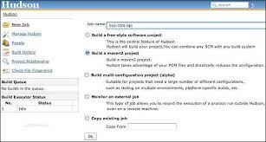
Hudson considers each project build as job. Once a project code is checked-in to SVN (or any Source Management Tool mapped to Hudson), Hudson starts its build job and once this job gets completed, it start other dependent jobs (other dependent projects) automatically.

DEPLOYMENT AUTOMATION
In project development, normally a deployment process consists of the following steps: •
- Check-in the code from all project in progress into the SVN (version control system) or source code repository and tag it. •
- Download the complete source code from SVN. •
- Build the application. •
- Store the build output either WAR or EAR file to a common network location. •
- Get the file from network and deploy the file to the production site.
- Updated the documentation with date and updated version number of the application.•
Automate the deployment process by combining the following: •
- Maven, to build and release projects. •
- SubVersion, source code repository, to manage source code.
- Remote Repository Manager (Jfrog/Nexus) to manage project binaries.•

In Pom.xml, following are the important elements we have used:
Element | Description
SCM | Configures the SVN location from where Maven will check out the source code.
Repositories | Location where built WAR/EAR/JAR or any other artifact will be stored after code build is successful.
Plugin | maven-release-plugin is configured to automate the deployment process.

ECLIPSE IDE INTEGRATION
Some of features of m2eclipse are listed below: •
- You can run Maven goals from Eclipse. •
- You can view the output of Maven commands inside the Eclipse, using its own console. •
- You can update maven dependencies with IDE. •
- You can Launch Maven builds from within Eclipse. •
- It does the dependency management for Eclipse build path based on Maven's pom.xml. •
- It resolves Maven dependencies from the Eclipse workspace without installing to local Maven repository (requires dependency project be in same workspace). •
- It automatic downloads the required dependencies and sources from the remote Maven repositories. •
- It provides wizards for creating new Maven projects, pom.xml and to enable Maven support on existing projects.
- It provides quick search for dependencies in remote Maven repositories. •
Installing m2eclipse Plugin:
Use one of the following links to install m2eclipse:
Eclipse | URL
Eclipse 3.5 (Galileo) | Installing m2eclipse in Eclipse 3.5 (Galileo)
Eclipse 3.6 (Helios) | Installing m2eclipse in Eclipse 3.6 (Helios)

- Create a Maven Project:
Step-1. Create a new Maven project via
File --> New --> Other…​ --> Maven --> Maven Project.

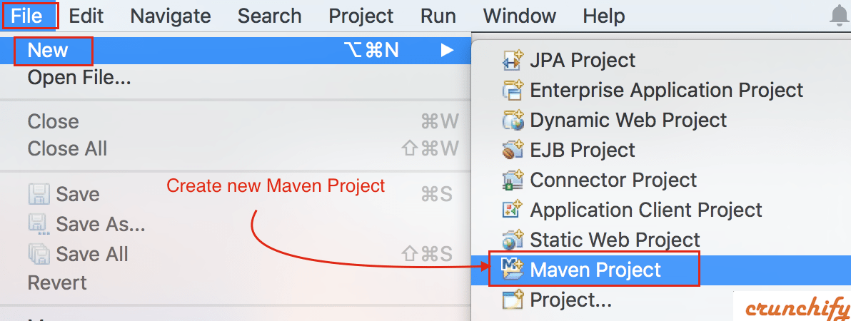
Step-2. Click on check box for both.
- Create a simple project.
- Use default workspace location.

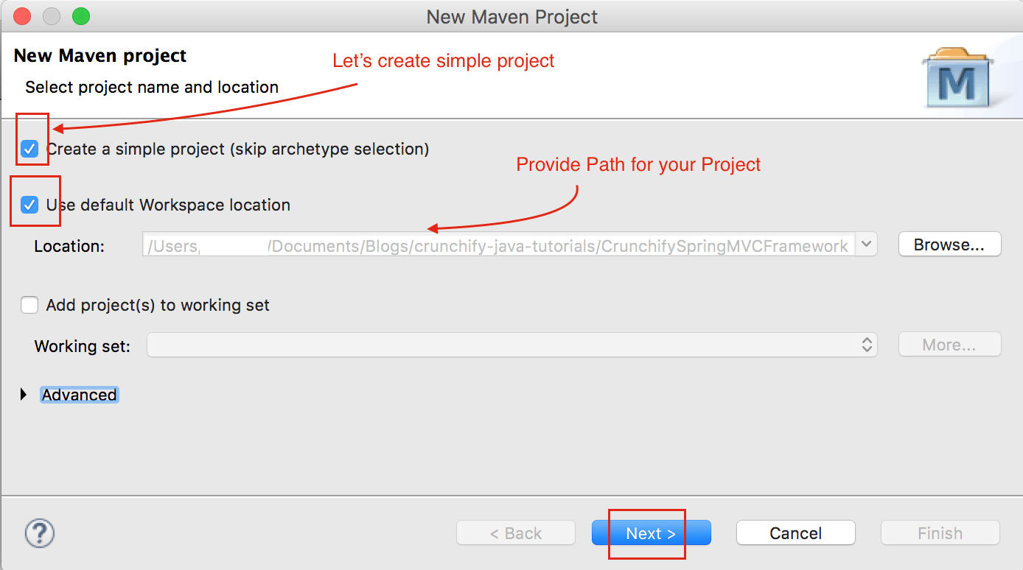

Step-3. Provide GroupId and ArtifactId in next screen.
- GroupId: com.companyname
- ArtifactId: Projectname
- Name: Maven_info
- Description:As per you need
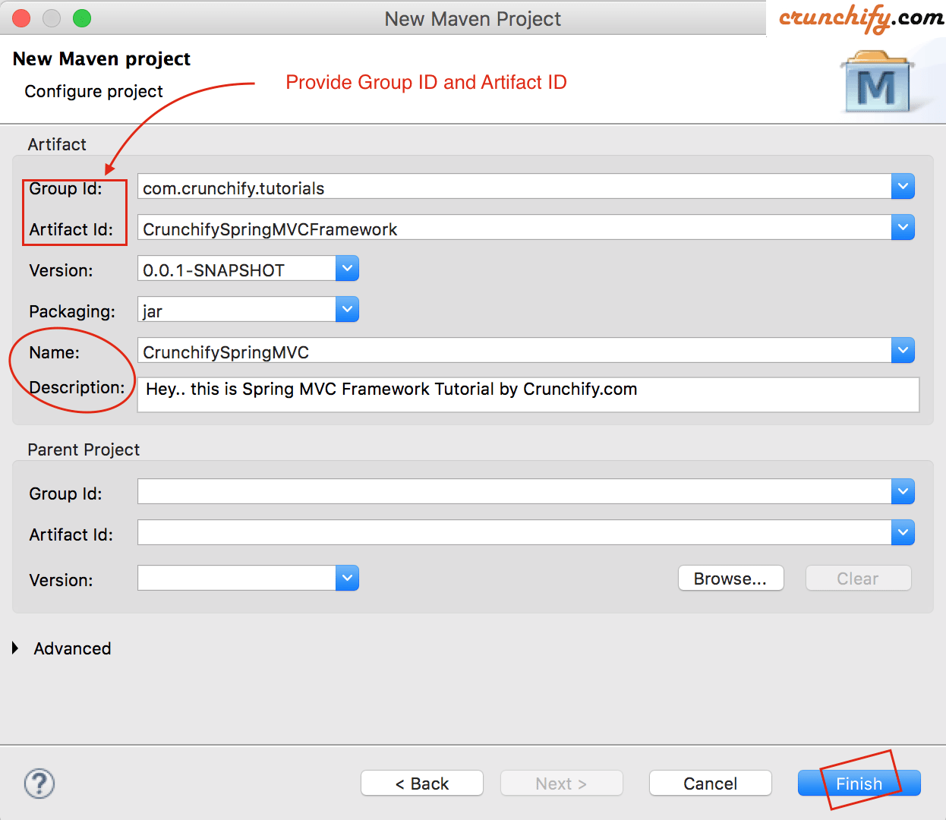

Step-4. And you are all set. You should see new Project in Eclipse with below structure.
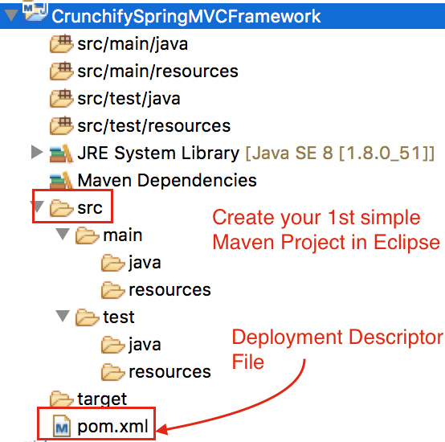
Step-5. Open pom.xml file. Checkout all properties and get familiar with those.

- Run the Maven Build:
Step-1. Validate that the generate setup works correctly by running the build. For this right-click the pom.xml file and select Run As --> Maven build.
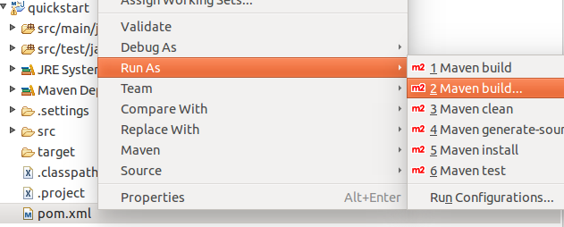
Step-2. This opens a dialog which allows to define the parameters for the start. Enter clean verify in the Goals: field and press the ”Run” button.
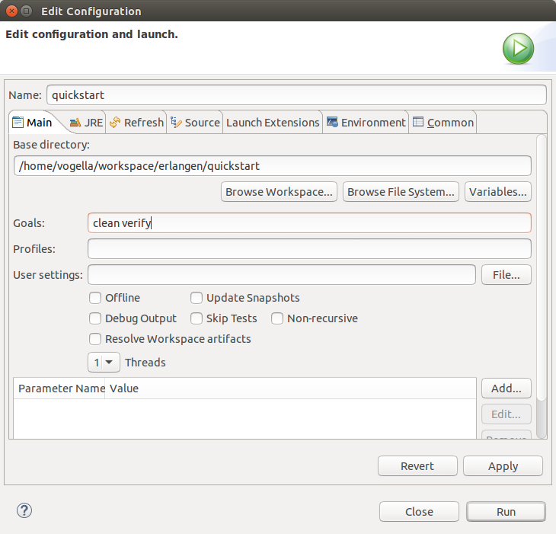

Adding dependencies to your project:
The Eclipse Maven tooling makes adding dependencies to the classpath of your project simple. In can directly add it to your pom file, or use the Dependencies tab of the pom editor.
Switch to the Dependencies tab and press the ”Add” button.

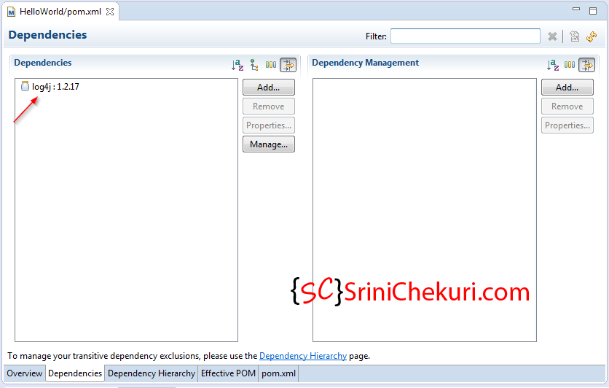

In this example we add Gson as dependency. For this we use the GAV which we found via the http://search.maven.orgwebsite. If the Maven index was downloaded (See [maven_eclipseinstallation_index] you can also search directly this dependency via the dialog.

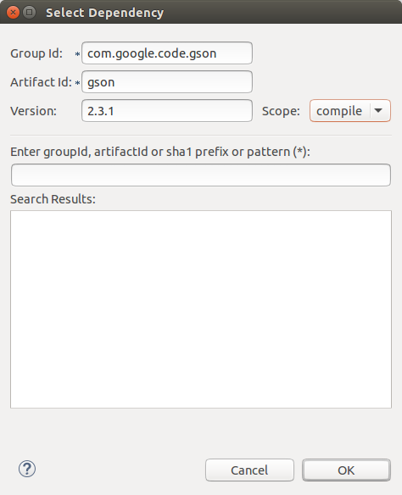

- Use Library:
Change or create the App.java class in your src/main/java folder. This classes uses Gson. As Maven added it to your classpath, it should compile and you should be able to start the class via Eclipse.
Ex:
package com.vogella.maven.lars;
import com.google.gson.Gson;
public class App
{
public static void main( String[] args )
{
Gson gson = new Gson();
System.out.println(gson.toJson("Hello World!") );
}
}
- Add Maven support to Java Project in Eclipse:

Step-1. Create Java project:
Create a new Java project called com.vogella.build.maven.simple in Eclipse.
Add one class called Main. This class should have a main method, which write "Hello Maven!" to the command line.

package com.vogella.build.maven.simple;
public class Main
{
public static void main(String[] args) {
System.out.println("Hello Maven!");
}
}

- Convert to Maven Project:
Select your project, right-click on it and select Configure ▸ Convert to Maven project
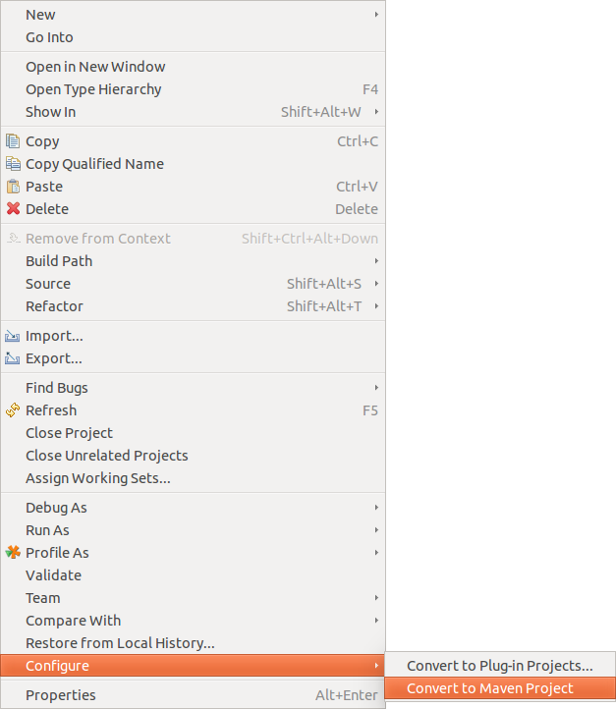

This creates a pom.xml file similar to the following.
<project
xmlns="http://maven.apache.org/POM/4.0.0"
xmlns:xsi="http://www.w3.org/2001/XMLSchema-instance"
xsi:schemaLocation="http://maven.apache.org/POM/4.0.0 http://maven.apache.org/xsd/maven-4.0.0.xsd">
<modelVersion>4.0.0</modelVersion>
<groupId>com.vogella.build.maven.simple</groupId>
<artifactId>com.vogella.build.maven.simple</artifactId>
<version>0.0.1-SNAPSHOT</version>
<build>
<sourceDirectory>src</sourceDirectory>
<plugins>
<plugin>
<artifactId>maven-compiler-plugin</artifactId>
<version>3.1</version>
<configuration>
<source>1.8</source>
<target>1.8</target>
</configuration>
</plugin>
</plugins>
</build>
</project>
- Execute The Maven Build:
Right-click the pom.xml file and select Run As ▸ Maven build.

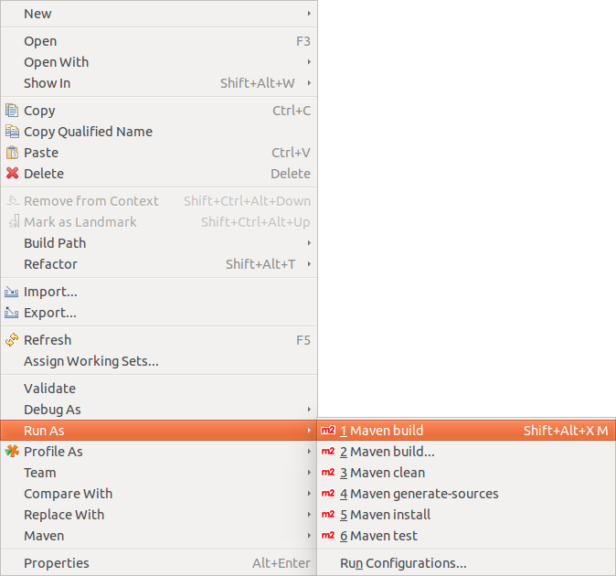
Enter "clean install" as Goal.
Note: You have to enter the goals manually. The ”select” button does not work, the dialog it displays is always empty.
Press the ”Finish” button. This starts the build, which you can follow in the Console view.
Once the build finishes, press F5 on the project to refresh it. You see a target folder, which contains the build artifacts, e.g., a JAR file.

YOUTUBE VIDEO LINK:
https://www.youtube.com/watch?v=zPg5aPjh-sA

